Mobile Podiatry Services
Felicia D. Benson, BS, CSA
Certified Senior Advisor
Felicia has worked in the healthcare industry since 2001.
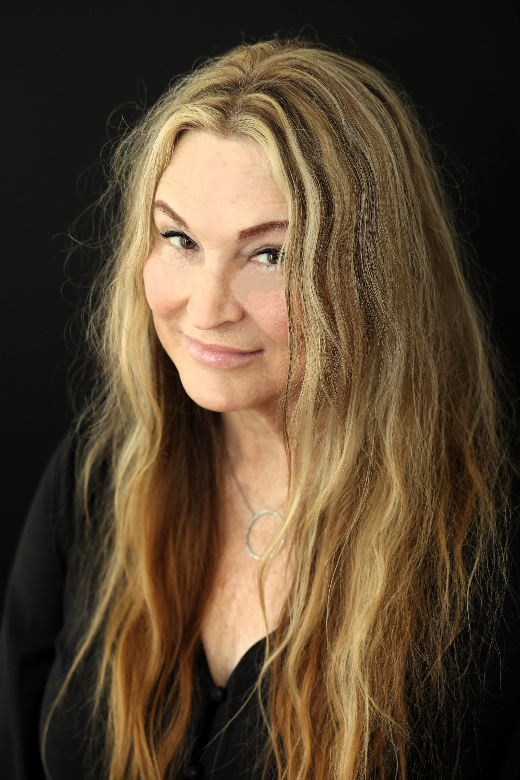
She’s a member of the Society of Certified Senior Advisors
and is proud to serve as Netcare’s Secretary of the Board.
Felicia earned her degree in Business Management from
Rosemont College and has served on various boards and
committees including The Chester County Office of Aging
Advisory Council, the Coatesville Area Senior Center, and
the Professional Care Alliance of the Delaware Valley, to
name a few.
Her background includes non-medical home care, senior living placement services, and durable medical equipment sales. She currently works part time for Saji Enterprises, P.C., marketing mobile podiatry services and coordinating start up at new communities. Felicia also manages the credentialing process, creates policies and procedures, and works on various other administrative projects. The mobile podiatry practice serves residents at assisted living and personal care homes, 55+ communities, and skilled nursing and rehab centers in southeastern Pennsylvania. Medicare, Medicaid and most insurances are accepted.
On a personal note, Felicia and her husband live on a small farm in Chester County where they’ve rescued animals both large and small. They’re also a vendor at Downingtown Vintage & Home Decor. If you would like to contact Felicia, her work cell is 215-990-0670, and her email address is felicia@drsimondpm.com.
P.O. Box 60310, King of Prussia, PA 19406
Office 215-990-9015 * Fax 215-979-6720

